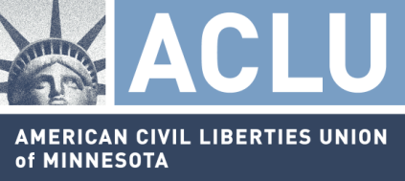

Statement of the ACLU of Minnesota
In Support of HF 389
House Public Safety and Security Policy and Finance Committee
February 23, 2017

The ACLU of Minnesota (ACLU-MN) is a nonpartisan, nonprofit organization dedicated to defending the civil liberties of all Minnesotans under the United States and Minnesota constitutions. We have over 38,000 supporters throughout Minnesota, and promote our mission through litigation, public education and lobbying efforts.

The ACLU-MN strongly supports HF 389. This bill reestablishes a level of due process for innocent joint-owners to file a claim in court when their jointly-owned vehicle is seized due to the other joint-owner’s violation of Minnesota’s DWI laws. The bill is limited to addressing the discrete issue created by the Minnesota Supreme Court’s statutory interpretation in Laase v. 2007 Chevrolet Tahoe.

The ACLU-MN has advocated for reforms to Minnesota’s civil asset forfeiture statutes for a number of years. HF 389 is an important step in the right direction.

We respectfully encourage the Committee’s support of HF 389.

